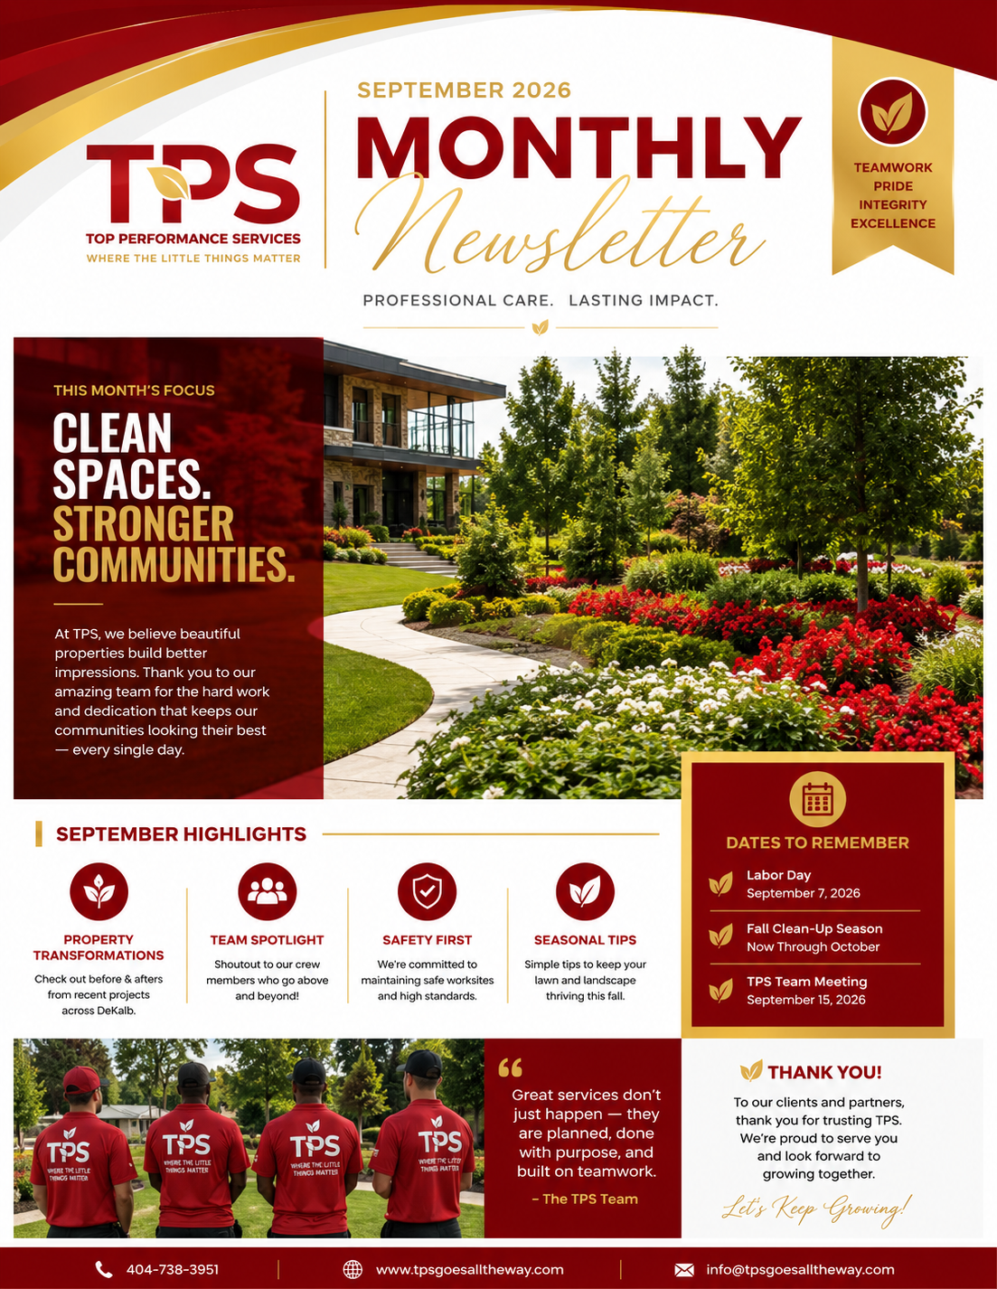
SEPTEMBER 2026 | PROFESSIONAL CARE. LASTING IMPACT.

CLEAN SPACES. STRONGER COMMUNITIES.
At TPS, we believe beautiful, clean and well-maintained properties build better impressions, stronger communities and greater pride.
A MESSAGE FROM TPS

September marks a new season and a fresh opportunity to take pride in the places we manage, maintain and serve. At Top Performance Services, our goal is simple: provide dependable property care with attention to the details that others may overlook. From lawn care and grounds maintenance to cleanup, pressure washing, landscaping and facility support, our team works to keep every property looking its best. Thank you to our clients, partners and team members for trusting TPS. We are proud of the work we do and excited about what is ahead.
SEPTEMBER SERVICE SPOTLIGHT

FALL PROPERTY CLEANUP & MAINTENANCE  As summer winds down, properties need attention before fall conditions arrive. TPS can help prepare and maintain your property through seasonal changes. | WHAT TPS CAN HANDLE  • Lawn care & mowing  • Landscape maintenance  • Yard & debris cleanup  • Tree & brush cleanup  • Mulching & bed maintenance  • Pressure washing  • Groundskeeping  • Property maintenance  • Storm cleanup  • Janitorial & facility support
TPS IN ACTION | PROPERTY TRANSFORMATION

FROM OVERGROWN TO ORDERLY • FROM BLIGHT TO BRIGHT • FROM WORK TO RESULTS
Use this section each month to feature real TPS before-and-after photos. Show the starting condition, the work completed and the finished result.
BEFORE  PHOTO  PLACEHOLDER | TPS IN ACTION  PHOTO  PLACEHOLDER | AFTER  PHOTO  PLACEHOLDER
TEAM SPOTLIGHT

Great service does not happen by accident. It takes people who show up, communicate, work safely and take ownership of the finished product. This month, TPS recognizes the entire team for the work happening behind the scenes and in the field.
TEAMWORK • PRIDE • INTEGRITY • EXCELLENCE
SEPTEMBER PROPERTY CARE TIPS

# | TIP | WHY IT MATTERS
01 | Keep lawns maintained | Continue mowing on the proper schedule and avoid allowing grass to become excessively overgrown.
02 | Clean beds & edges | Remove weeds, litter and debris so landscaped areas remain defined and presentable.
03 | Inspect drainage | Clear visible debris from drainage paths, catch basins and areas where water may collect.
04 | Prepare for fall | Begin planning seasonal cleanup, leaf removal, pruning and other fall maintenance needs.
05 | Look up & around | Check trees, branches, signage, walkways and exterior areas for hazards or maintenance concerns.
SEPTEMBER DATES TO REMEMBER

September 7, 2026 | Labor Day — A day to recognize the value of hard work and the people who keep our communities moving.
September 15, 2026 | TPS Team Meeting — Use for internal team communication, training, updates and upcoming priorities.
September–October | Fall Clean-Up Season — Begin scheduling seasonal cleanup, grounds maintenance and property preparation.
TPS SERVICES | MORE THAN MAINTENANCE

LANDSCAPING | Landscape design/maintenance, planting, beds, mulch and property beautification.
LAWN CARE | Mowing, edging, trimming, blowing, turf care and routine lawn maintenance.
GROUNDSKEEPING | Routine grounds care, litter/debris removal, common-area maintenance and presentation.
TREE & BRUSH | Tree-related cleanup, brush removal, pruning support and storm-related debris cleanup.
PROPERTY MAINTENANCE | Exterior upkeep, seasonal maintenance, property preservation and general site support.
PRESSURE WASHING | Exterior surface cleaning for sidewalks, entries, buildings and other hard surfaces.
JANITORIAL | Interior cleaning, restroom care, common-area cleaning and facility support.
STORM CLEANUP | Post-storm debris removal, site cleanup and restoration support.
SEASONAL SERVICES | Fall cleanup, leaf/debris removal and preparation for changing weather conditions.
THANK YOU

TO OUR CLIENTS, PARTNERS & COMMUNITY
Thank you for trusting Top Performance Services. Every property we care for is an opportunity to demonstrate our commitment to quality, consistency and the little things that make a big difference.
“WHERE THE LITTLE THINGS MATTER.”
READY FOR A CLEANER, BETTER-MAINTAINED PROPERTY?
Schedule your September property maintenance, cleanup or facility service with TPS.
TOP PERFORMANCE SERVICES (TPS)
Professional Care. Lasting Impact.
WHERE THE LITTLE THINGS MATTER.
Phone: 404-738-3951 | Email: info@tpsgoesalltheway.com | Website: www.tpsgoesalltheway.com

